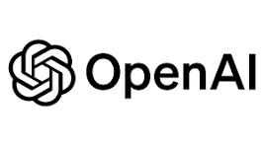

**Product Dissection for ChatGPT**

## 1. Company Overview

OpenAI is an artificial intelligence research and deployment company founded in 2015 with the mission to ensure that artificial general intelligence (AGI) benefits all of humanity.

Headquartered in San Francisco, OpenAI is best known for developing the GPT (Generative Pre-trained Transformer) models, including **ChatGPT**—an AI-powered conversational assistant capable of understanding and generating human-like text.

OpenAI operates on a **freemium and enterprise model**, offering services to individuals, developers, and businesses through products like ChatGPT, DALL·E, Whisper, and the OpenAI API. The company partners with major tech firms such as **Microsoft and Apple** to integrate its AI tools across platforms, making advanced AI accessible and useful at scale.

## 2. Product Dissection and Real-World Problems Solved

ChatGPT is an advanced AI chatbot developed by OpenAI, built on the GPT architecture. It uses deep learning techniques to understand and generate human-like language, enabling interactive, context-aware conversations.

With the launch of **GPT-4o**, ChatGPT became multimodal—capable of processing not just text but also images and audio—making it a versatile tool for communication, education, and productivity.

It is accessible through a web app, mobile apps, and API integrations, making it widely usable for individuals, developers, and businesses.

### 2.1 Problem 1: Limited Access to Quality Education and Personalized Learning

**Challenge:** Many students worldwide lack access to quality tutors or learning resources, especially in underprivileged or remote areas. Traditional classroom settings often fail to meet individual learning needs.

**Solution:** ChatGPT acts as a 24/7 AI tutor that explains complex topics in simple language, answers questions, generates quizzes, and adapts to each learner’s pace. It supports multiple subjects such as math, science, coding, and languages—helping bridge educational gaps.

**Impact:**

* Used by millions of students globally for homework help and exampreparation.
* Teachers design lesson plans and learning materials with its support.
* Increases self-learning opportunities where human resources are limited.

### 2.2 Problem 2: Time-Consuming and Repetitive Business Tasks

**Challenge:** Businesses waste time on repetitive tasks such as drafting emails, responding to customer queries, and writing reports—leading to lower productivity.

**Solution:** ChatGPT automates tasks such as generating emails, creating reports, summarizing meetings, and writing code. It also powers AI chatbots in customer service.

**Impact:**

* Small businesses save time and reduce customer support costs.
* Enterprises boost employee productivity.
* Developers accelerate coding and debugging.

### 2.3 Problem 3: Language Barriers in Global Communication

**Challenge:** Language differences hinder collaboration, education, and customer service in multilingual environments.

**Solution:** ChatGPT supports real-time translation and multilingual communication. With GPT-4o, it handles text, voice, and images across languages.

**Impact:**

* Enhances global collaboration.
* Enables non-English speakers to access information.
* Reduces reliance on translators for everyday tasks.

### 2.4 Problem 4: Accessibility for People with Disabilities

**Challenge:** People with visual, hearing, or cognitive impairments face barriers in accessing digital content.

**Solution:** OpenAI integrates text-to-speech, speech-to-text, and image understanding into ChatGPT, enabling inclusive interactions.

**Impact:**

* Empowers visually impaired users with descriptive content.
* Enables voice-based interaction for those who struggle with typing.
* Supports inclusive design in workplaces and education.

### 2.5 Problem 5: Mental Health Support Gaps

**Challenge:** Millions lack affordable mental health support due to stigma, cost, or limited providers.

**Solution (with caution):** ChatGPT provides a safe space for journaling, guided meditation, stress relief, and emotional support—while not replacing professional therapy.

**Impact:**

* Encourages self-reflection and awareness.
* Helps manage stress and anxiety in real time.
* Promotes mental health awareness.

## 3. Top Features of OpenAI

### 3.1 ChatGPT (GPT-4o)

* Handles text, image, audio, and video inputs.
* Natural, context-aware conversations.
* Custom instructions for tone and style.
* Real-time voice mode (Pro).
* Image analysis and code execution.
* File uploads for data analysis.

### 3.2 DALL·E

* AI image generation from text prompts.
* Inpainting for image editing.
* Style control (realistic, artistic, cartoon).
* Integrated with ChatGPT.

### 3.3 OpenAI API (for Developers)

* Access to GPT-4o and GPT-3.5.
* Fine-tuning options.
* Function calling and embeddings.
* Assistants API for building custom AI agents.

### 3.4 Safety and Moderation Tools

* Built-in protections for users.
* Content filtering and bias control.
* Moderation API for harmful content detection.

### 3.5 ChatGPT Team & Enterprise

* Admin and privacy controls.
* Enterprise API access.
* Shared memory and collaboration tools.

## Schema Description

The schema for ChatGPT involves multiple entities that represent various components of the conversational AI system. These entities capture how users interact with the assistant, how messages are structured, how tools and functions are called, and how conversations are stored and maintained. Each entity has specific attributes describing its purpose and relationship to others.

**User Entity**

Represents end-users interacting with ChatGPT.

* **User-ID(Primary Key):** A unique identifier for each user.
* **Full_Name**: The full name of the user (if available).
* **Email**: User's email for authentication and communication.
* **Subscription_Tier**: Type of plan (Free, Plus, Team, Enterprise).**Summary:** A description or bio provided by the user.
* **Registration_Date**: Date the user registered.**Registration_Date:** The date the user joined Linked In.
* **Preferences**: JSON storing user-specific preferences or settings.
* **Memory_Status**: Whether memory is enabled/disabled for the user.

Message Entity

Stores all messages exchanged during a chat session

:

* **Message-ID (Primary Key)**: Unique ID for each message.
* **Conversation-ID (Foreign Key)**: The conversation to which the message belongs.
* **User-ID (Foreign Key)**: Sender user (nullable if sent by assistant).
* **Role**: Role of the sender (user, assistant, system, tool)
* **Content**: Message text or tool call result.
* **Timestamp**: Time when the message was sent.
* **Tool_Call_ID (optional)**: ID linking to tool invocation.
* **Is_Function_Call**: Boolean indicating if the message triggered a function/tool.
* .

**Conversation Entity**

Captures the entire chat history per session or topic:

* **Conversation-ID (Primary Key)**: Unique identifier for each conversation..
* **User-ID (Foreign Key)**: The user having the conversation.**Content:** Text or media shared in the post.
* **Start_Time**: When the conversation started.
* **End_Time**:When the conversation ended (nullable)
* **End_Time**: When the conversation ended (nullable)
* **Title**: Custom or auto-generated title for the conversation.
* **Status**: Active, Archived, or Deleted.

.

**Tool Entity**

Tracks when the assistant calls a tool or function during a chat.

* · **Tool_Call_ID (Primary Key)**: Unique ID for the tool call.
* · **Conversation-ID (Foreign Key)**: Conversation in which the tool was called.
* · **Tool-ID (Foreign Key)**: Tool being used.
* · **Arguments**: JSON string with the function parameters.
* · **Call_Timestamp**: When the call was made.
* · **Response**: Output from the tool/function.

**Memory Entity**

Represents stored long-term information about the user.

* · **Memory-ID (Primary Key)**: Unique ID for memory entry.
* · **User-ID (Foreign Key)**: Associated user.
* · **Key**: Topic or type of memory (e.g., Name, Favorite Language).
* · **Value**: Stored data or preference.
* · **Last_Updated**: When the memory was last changed.
* · **Status**: Active, Deleted, or Archived.

**FileUpload Entity**

Tracks files uploaded by users during conversations.

* · **File-ID (Primary Key)**: Unique ID for each uploaded file.
* · **User-ID (Foreign Key)**: Who uploaded the file.
* · **Conversation-ID (Foreign Key)**: Where the file was used.
* · **File_Type**: PDF, Excel, Image, etc.
* · **File_URL**: Link to stored file.
* · **Upload_Timestamp**: When the file was uploaded.

VoiceInteraction **Entity**

Used in voice mode (mobile apps) to track spoken inputs and outputs.

* · **Voice-ID (Primary Key)**: Unique identifier for each voice interaction.
* · **User-ID (Foreign Key)**: The speaker or listener.
* · **Transcript**: Text version of the spoken input.
* · **Audio_URL**: Link to audio file.
* · **Direction**: input or output.
* · **Timestamp**: When the voice interaction happened.

**Relationships**:

* · **Users start Conversations**: A user can have many conversations.
* · **Conversations have Messages**: Each chat stores a sequence of messages.
* · **Assistant uses Tools**: Tools can be called in conversations via ToolCall.
* · **Messages may invoke ToolCalls**: Assistant messages may include function calls.
* · **Users upload Files**: Files are linked to both users and conversations.
* · **Users may have Memory**: Long-term memory is linked per user.
* · **Voice interactions** are linked to Users and Conversations.

**ER Diagram:**

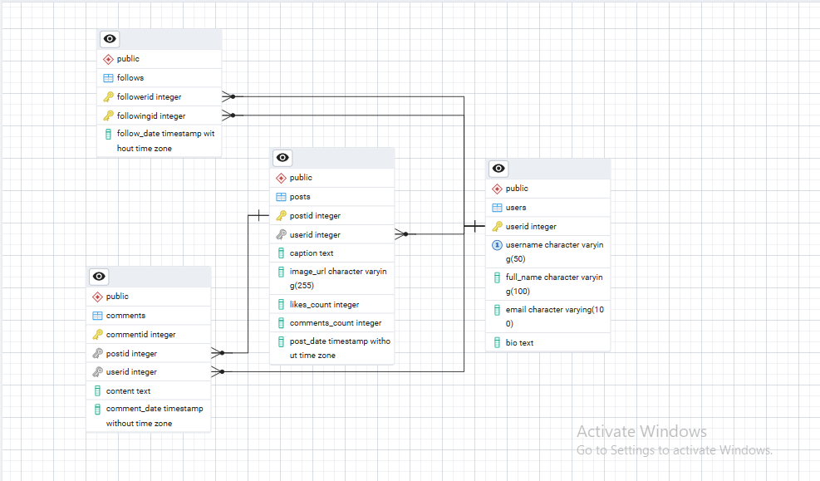

**Conclusion**

In this case study, we examined the design of ChatGPT’s schema and its Entity-Relationship diagram. ChatGPT has transformed the way people interact with artificial intelligence, enabling seamless, natural language conversations and providing intelligent assistance across diverse domains.

Through this schema, we gain an understanding of how ChatGPT manages user interactions, conversations, and tool integrations while maintaining a personalized and context-aware experience. Its flexible and scalable data architecture supports continuous learning and enhancement, driving widespread adoption and ongoing innovation. ChatGPT’s design empowers users and developers alike, advancing the capabilities and accessibility of AI-driven communication.